Sustainable Air Quality Prediction and Alert System Using IoT
Divyansh Gautam^{1, a)} Omkar Patange^{1, b)} Dr. S. Ramesh^{2, c)}
Author Affiliations

¹ B.Tech CSE, Department of Computing Technologies, SRM Institute of Science and Technology, Kattankulathur, Chengalpattu, Tamil Nadu, India
² Associate Professor, Department of Computing Technologies, Faculty of Engineering and Technology, SRM Institute of Science and Technology, Kattankulathur, Chengalpattu, Tamil Nadu, India

Author Emails
^{a)} Corresponding author: divyanshgautam151@gmail.com
^{b)} work.omkarpatange@gmail.com
^{c)} ramesh.isaiah@gmail.com

Abstract— In this paper, the proposed design and development of an IoT-based real-time air quality monitoring and alert system is presented. In the proposed system, the most crucial elements, such as the NODEMCU ESP8266 microcontroller, MQ-135 Air Quality Sensor, and DHT11 Sensor, are combined to sense environmental parameters such as air quality, temperature, and humidity in real-time. The sensed data is uploaded to Google Sheets, where a SMA method is implemented to track trends and forecast air quality variations. For the public's safety, alerting is implemented based on Twilio, which provides real-time SMS notifications whenever pollutant concentrations exceed set limits. The system is scalable and flexible, and thus it is deployable in a broad range of environments, from a single indoor space to the entire city, for proactive air quality management.

Introduction
Air pollution has developed as a transboundary issue of concern, owing to accelerated urbanization and industrialization. An expanding concentration of air pollutants within the environment necessitated the integration of effective management policies for air quality. Current conventional air quality monitoring systems are important but do not normally comprise integration with real-time data as well as prediction models. That absence diminishes their ability to drive timely response as well as decision-making and makes populations susceptible to the deleterious health outcomes of pollution.
To tackle such challenges, there has been an increasing demand for developing sophisticated air quality monitoring systems with real-time data acquisition and incorporation of prediction analysis. In this paper, development of an IoT-based air quality monitoring and forecasting system using a Simple Moving Average (SMA) approach for air pollution trend forecasting is presented. The system, with an uninterrupted chain of environmental data acquisition and processing, delivers actionable intelligence to facilitate people and authorities to take preventive measures to improve air quality. The final goal of this research is the development of an efficient, scalable, and integrated monitoring system with the potential of IoT technology.
The system incorporates the use of a combination of the NODEMCU ESP8266 microcontroller, air sensors, and DHT11 sensors to measure and analyze environmental data. With the SMA approach, the system can predict future patterns in air quality, giving a broader view of trends in pollution. The system also incorporates an alert system that issues timely alarms when air conditions are hazardous, ensuring public safety. Such an integration of real-time monitoring, predictive analysis, and alerting makes the system a very efficient instrument in addressing challenges of air pollution management.

LITERATURE REVIEW
Recent research articles indicate the growing interest in IoT-based air quality monitoring and predictive analysis. Samal et al. [1] developed an IoT-based monitoring system with integrated stationary and mobile sensors. Its application is, however, restricted due to the lack of an emergency alerting system, and it takes time to react to extreme air quality emergencies. Likewise, Gupta et al. [2] used the Prophet algorithm to deliver seasonal AQI trend analysis with high accuracy levels of prediction, but their system does not include the real-time monitoring aspect crucial for taking timely action. Kovacs and Rusu-Both [3] used machine learning for IoT-based indoor air quality prediction. Their model is credible but not for solving the issue of scalability and integration of various sensors crucial for mass use. Lima et al. [4] offered real-time data and machine learning usage for efficient air quality management in cities, but the lack of an automated alert system reduces its usability in situations where urgency demands action. Mohamad et al. [5] developed an IoT-based predictive analysis system for public health security, but the low level of flexibility for adaptability reduces its usability in a variety of environmental settings.
The role of advanced machine learning models in AQI prediction has been investigated in numerous studies. Zhang et al. [6] emphasized the importance of scalable IoT platforms for predictive urban air quality modeling. Chen et al. [7] and Wang et al. [8] used high-performance neural networks (LSTMs) for precise pollutant level prediction. While these models resulted in greater prediction accuracy, their extensive computational overhead limits their deployment in low-power IoT devices. Nguyen et al. [9] suggested hybrid models to improve prediction reliability, especially in real-world applications. Park et al. [10] investigated long-term reliability of IoT sensor calibration, which is an important factor in enabling accurate air quality measurement in the long term. Rao et al. [11] also integrated edge computing with IoT-based air quality monitoring to reduce latency and improve real-time responsiveness in cities. Pereira et al. [12] investigated air quality prediction issues in smart cities by proposing better IoT networks and advanced algorithms for better forecasting accuracy.
Several studies have appeared that have stressed IoT-based AQI prediction models. Nguyen et al. [13] have proposed a scalable and accurate data-driven AQI prediction model, whereas Xu et al. [14] utilized hybrid machine learning models to enhance the accuracy of forecasting with minimal computational cost. Kim et al. [15] have proposed an IoT-based real-time monitoring system with stress on data accuracy for better decision-making. Singh et al. [16] have studied PM2.5 and PM10 pollution trends employing IoT and machine learning. Li et al. [17] employed a deep learning-based IoT system for real-time air quality analysis, whereas Nguyen et al. [18] have proposed a smart IoT system for real-time AQI prediction with focus on efficient data collection and processing. Other research has examined IoT architectures for diverse scenarios. Sharma et al. [19] designed a hybrid IoT architecture for rural and urban air quality monitoring. Zhang et al. [20] demonstrated an intelligent air quality management system with advanced predictive analytics for environmental flexibility. Despite these advancements, there are still gaps in real-time alerting, sensor calibration, and large-scale deployment. This paper fills these gaps with the proposal of an IoT-based air quality monitoring system with real-time alerts, predictive analytics (SMA-based), and large-scale deployment, offering a cost-effective and adaptive air quality management system.

METHODOLOGY
The system proposed works on a systematic process to track air quality, analyze trends, and provide real-time alerts. The system begins with sensors that are the primary sources of information, tracking environmental parameters like air pollutants, temperature, and humidity in real time. The sensors provide real-time information, which ensures accurate monitoring of atmospheric conditions. The raw data gathered is input into a microcontroller, where it undergoes an initial processing stage. Preprocessing is the elimination of noise and reorganizing the data into a usable form before it is sent for analysis. The microcontroller eliminates only meaningful and relevant data to be sent for assessment.
To enable efficient management of data and support smooth cloud integration, a separate DataCollector component is employed. The component structures, organizes, and formats the gathered data prior to transmission to a cloud-based system through the Google Sheets API. The cloud-based storage system supports secure logging of historical and real-time data and makes it available for trend analysis. The Simple Moving Average (SMA) method is then employed to process the stored data to enable the detection of air quality variations. Through processing of past and real-time measurements, the system is able to identify patterns and predict possible variations in air quality. Upon analysis, where instances of air quality parameters beyond set values are identified, an alert system is initiated, enabling timely intervention. When it detects critical air pollution levels, the system initiates an automated alert system via Twilio SMS notifications, which instantly notifies users of possible environmental hazards. This end-to-end process—from data collection to cloud storage, analysis, and alert generation—is an integrated and efficient air quality monitoring system. The modular architecture of the system allows for seamless scalability, making its deployment in any setting such as cities, industrial areas, and residential neighborhoods possible. Cloud storage also optimizes the reliability and accuracy of the system so that users can get real-time updates for anticipatory decision-making.

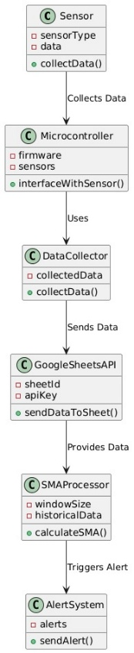
Fig. 1. IoT System Workflow

PROPOSED SYSTEM
The air quality monitoring system described here is a complete real-time environmental monitoring system utilizing the newest components for efficiency and accuracy. The NODEMCU ESP8266 microcontroller is the core of the system as the main interface for data acquisition and transmission. The microcontroller is powered by an Air Quality Sensor and a DHT11 sensor, allowing the system to monitor essential environmental factors such as air quality, temperature, and humidity. The Air Quality Sensor monitors concentrations of pollutants such as gases like carbon monoxide, while the DHT11 sensor monitors temperature and humidity, giving a complete environmental picture of the factors influencing air quality.
Once data is gathered, it is transferred to Google Sheets for cloud storage and initial processing. A cloud-based data management approach allows for effective data management by classifying current as well as past records in a systematic manner. It allows for seamless cross-device access, enabling users and researchers to track current and past trends in real-time from anywhere with an internet connection. The systematic storage of data also allows for simpler analysis, which can aid in making informed decisions about air quality conditions.
For real-time feedback, the system employs Twilio's SMS service to notify users whenever air quality parameters exceed set thresholds. Users are automatically alerted by SMS on sudden increases in pollutants, enabling users to respond in time, e.g., by enhancing ventilation or minimizing exposure. The efficient and timely messaging system reminds users at the right time, preventing potential health hazards due to substandard air quality. Scalable and flexible in architecture, the system is suitable in different applications, ranging from single-family house to cityscape. Modular in system architecture, the system is simple to integrate more sensors and customize for specific monitoring applications. Used in residential, commercial, or city-scale projects, the system offers a safe and flexible solution for overall air quality monitoring that delivers a safer and a healthier environment.

SYSTEM DESIGN AND IMPLEMENTATION
System design also comprises various essential hardware components. The core unit of the data collection and relay is NodeMCU ESP8266 Wi-Fi development board. The MQ-135 gas sensor detects harmful pollutants in the environment, while the DHT11 sensor provides supplementary information about temperature and humidity. All such sensors are very important in the collection of a large amount of environmental data to monitor air quality effectively.
Data transmission in the system is designed for smooth operation. Sensor readings are gathered and uploaded over Wi-Fi to Google Sheets, where data is stored and categorized for future analysis. Rather than using a machine learning algorithm, the system uses a Simple Moving Average (SMA) technique to interpret air quality patterns from past records. This helps in smoothing fluctuations and identifying key trends in the pollution levels. If air quality readings are found to cross-set thresholds, the system sends out automated SMS alerts through Twilio, providing real-time notifications to users.
An IoT-based air quality monitoring system is based on the interfacing of two significant sensors: the MQ-135 gas sensor to sense harmful gases and the DHT11 sensor to sense temperature and humidity. The sensors are interfaced with the NodeMCU ESP8266, which performs the processing of the data and sends it to the cloud for real-time monitoring.

- MQ -135 Gas Sensor:
The MQ-135 gas sensor works on the principle of sensing gas concentration and providing an analog signal, which is then processed by the microcontroller. It has three prominent pins: VCC (Voltage Input), GND (Ground), and Signal Pin, which are interfaced with the 3.3V, GND, and an analog input on the NodeMCU, respectively.

- DHT11 Sensor:
DHT11 sensor is used for sensing temperature and humidity and delivers digital signals to the microcontroller. It comes with four pins: VCC (power supply), GND (ground), Data Pin (for digital data transfer), and an unused NC (Not Connected) pin. The Data Pin is linked with a digital GPIO on the NodeMCU, which allows for faster data transfer.

- NodeMCU ESP8266:
NodeMCU ESP8266 is the system's processing unit. It receives analog air quality data from the MQ-135 sensor and digital temperature and humidity data from the DHT11 sensor. NodeMCU's built-in Wi-Fi module allows it to send the data collected to Google Sheets for real-time monitoring and insights based on data. The use of Simple Moving Average (SMA) calculations helps to provide a reliable indication of air quality trends. In case calculated SMA values indicate a dangerous level of pollution, the system automatically sends SMS alerts using Twilio for timely warnings.

Table 1. MQ-135 Sensor to ESP8266 Connection

MQ-135 | ESP8266
A0 | A0
GND | G
VCC | 3V

Table 2. DHT11 to ESP8266 Connection

DHT11 | ESP8266
Out | D2
GND | G
VCC | 3V

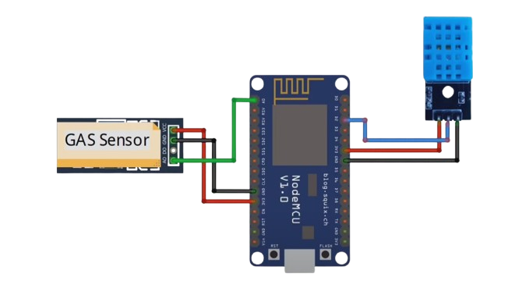
Fig. 2. Connection Diagram

The system connection diagram provides a detailed representation of the wiring layout, complete with a representation of how the MQ-135 gas sensor, DHT11 sensor, and NodeMCU ESP8266 are connected. Through this arrangement, real-time data processing and capture for air quality assessment are facilitated. Figure 3 represents the actual setup, with the wiring layout and checking for proper system functioning.

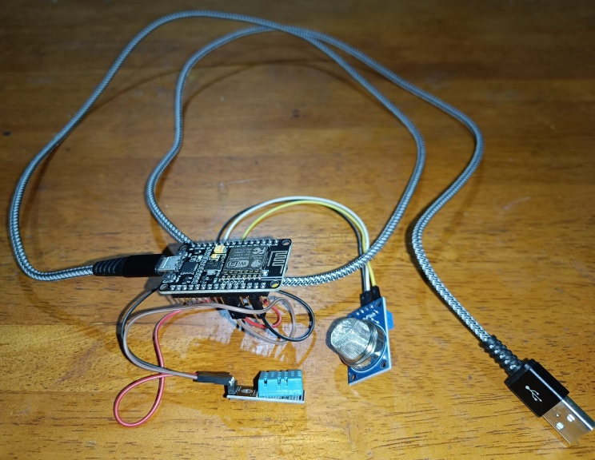
Fig. 3. IoT Device

ARCHITECTURE

The IoT-based air quality alerting and monitoring architecture proposed here is real-time in its functioning, ensuring the processing, data collection, and notification in real-time. Sensors, a microcontroller, integration with the cloud, and an auto-alerting system are the fundamental components of the system which work in an integrated manner in order to monitor air quality and alert users once air pollution values go beyond healthy limits.
- Devices and Control Unit:
The system employs multiple sensors for environmental parameter measurement. The MQ-135 gas sensor detects and monitors air pollutant concentration, while the DHT11 sensor detects temperature and humidity. The NodeMCU ESP8266 is used as the central processing unit to which the sensors are mounted. The onboard Wi-Fi NodeMCU ESP8266 reads real-time sensor data and transmits it to the cloud for monitoring and analysis. The configuration provides for continuous and accurate monitoring of air quality parameters.
- Information Transfer:
Once the microcontroller collects data from sensors, it transmits the data wirelessly via Wi-Fi to the cloud. The system relies on an external power source to ensure continuous operation. A Google Apps Script offers seamless data logging to Google Sheets, which acts as an interface between the IoT device and cloud storage. This arrangement offers efficient, real-time logging of data, and the sensor values are accessible for analysis and decision-making in real time.
- Cloud Integration and Data Processing:
The collected air quality data in Google Sheets are also processed using a Simple Moving Average (SMA) method. SMA considers historical sensor readings to establish air pollution trends. SMA is a method of smoothing data variability, providing true information about air quality variability without the complexity of machine learning algorithms. Scalability is enabled using the cloud-based system, and users can view and control big data sets from remote locations for continuous air quality assessment.
- Notification Framework:
Whenever air quality index as computed by SMA crosses pre-specified safety levels, the system automatically initiates real-time SMS alerts using the messaging interface provided by Twilio. This informs users immediately about hazardous levels of air quality so that they may take the required precautions. Automated warning removes the necessity for continual manual verification round the clock and hence is ideal for a host of applications wherein real-time data about air quality is most essential.
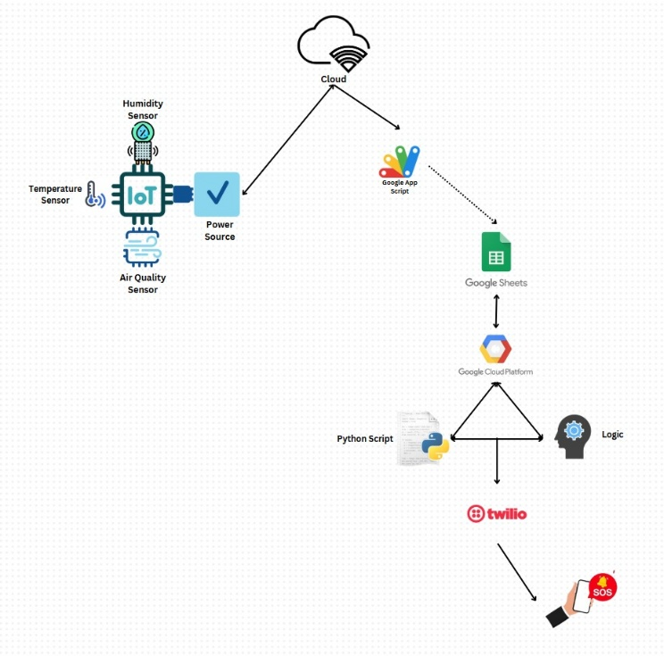
Fig. 4. Architecture Diagram

SIMPLE MOVING AVERAGE FOR AIR QUALITY

The system applies a Simple Moving Average (SMA) approach to identify air quality trends from previous sensor readings. Unlike sophisticated machine learning techniques, the SMA approach provides an efficient yet simple method of trend identification in pollutant concentrations. By averaging current air quality readings, the system removes the noises and identifies underlying trends over a long duration of time, allowing accurate estimation of the pollutant trends. The technique is extremely well suited for real-time monitoring as it suppresses the influence of short-term noises and puts in the limelight robust trends in air quality over the long term.
The data from air quality readings using the MQ-135 gas sensor and temperature and humidity using the DHT11 sensor are uploaded to Google Sheets. The entry for each record is timestamped to ensure organized record-keeping for trend monitoring. Raw sensor readings may include noise or a sudden spike, and the SMA approach eliminates this irregularity by calculating the mean of the past 5 or 10 recorded readings. This ensures a smooth reflection of air quality trends to allow for better detection of creeping rises in pollutant levels and alerting the users before danger strikes.
The SMA formula used in this approach is:

$$SM A_{n}=\frac{(X_{1}+X_{2}+…+X_{n})}{n}$$

Where $X_{1}, X_{2}, …, X_{n}$ are the latest air quality readings, and $n$ is the number of readings taken into account (e.g., the last 5 or 10 values). By ongoing re-calculation of this as new sensor data arrive, the system detects rising or falling trends in pollutant levels. If the SMA reading exceeds previously established safety limits, an automatic alarm is generated, alerting users to possible air quality decline.
The real-time monitoring and notification system guarantees that the instant the moving average indicates a consistent rise in pollutant levels, an automatic SMS alert is sent via Twilio. This guarantees timely notification to users, allowing them to take measures such as wearing masks, improving ventilation, or remaining indoors. The ability to detect deteriorating air quality in advance provides a preventive measure for minimizing health risks from poor air quality.
The SMA technique has several advantages over machine learning techniques. It is computationally efficient as it does not require large training data or complex algorithms, hence suitable for real-time IoT use. Additionally, by averaging the latest values, SMA filters noise and provides distinct trend signals, hence more precise in monitoring air quality variations. Easy to apply and deployable in Google Sheets, the SMA technique is scalable and simple with high precision in detecting pollution patterns.
By utilizing Simple Moving Average (SMA) trend analysis, the air quality prediction system provides real-time and accurate monitoring. Using this approach, the system is capable of real-time detection of pollution trends, enhancing environmental awareness and supporting decision-making in a preventive manner for the assurance of public health. The integration of IoT sensors, cloud logging, and SMA-based trend detection provides this system to be a powerful, trustworthy, and efficient air quality monitoring system.

ENVIRONMENTAL PARAMETER RANGES

The IoT setup monitors three environmental parameters of the utmost importance—temperature, humidity, and air quality—to compute environmental conditions in real-time. All three of them are divided into three classification levels: Low (Good), Moderate, and High (Unhealthy). Classification assists in easy-to-read measurement interpretation and immediately alerts users through notifications upon crossing critical levels. With real-time alert triggering upon these levels, the system provides users with proactive measures for improving air quality and developing an environment that is healthier.
Table 3. Classification of Environmental Parameter Ranges for Temperature, Humidity and Air Quality
S. NO | Parameter | Low (Good) | Moderate | High (Unhealthy)
1 | Temperature | 18°C - 24°C | 25°C - 29°C | 30°C and above
2 | Humidity | 30% - 50% | 51% - 70% | 71% and above
3 | Air Quality | 0 - 341 PPM | 342 - 682 PPM | 683 - 1023 PPM

The alert system uses Table 3 threshold values to trigger timely alerts and user protection, automatically sending alerts when any environment parameter crosses the "High (Unhealthy)" threshold—i.e., when the temperature goes beyond 30°C, humidity crosses 70%, or air quality crosses 683 PPM. When multiple parameters cross their critical points at the same time, the system triggers priority alerts to signify a significant environmental change. Twilio's SMS service is used to send automated alerts, the specific parameter(s) that crossed safe limits, the current reading of the environment, and recommended actions to counteract the condition. Through these timely alerts, the scheme allows users to act fast in response to worsening environmental conditions, improving health and safety.

RESULTS AND DISCUSSION

The system developed can monitor real-time air quality conditions in different atmospheres. Implementation with gas and DHT11 sensors and NodeMCU ESP8266 as the microcontroller provides accurate measurement of vital environment parameters like air quality, temperature, and humidity. Sensor data is read by the ESP8266 for data processing and storage to the cloud. The system is able to automatically update the Google Sheets dashboard for the sake of online real-time access and monitoring.
The chain of data processing is initiated by an executable script, which organizes and structures actual sensor data. The constant stream of data supplies stakeholders with instantaneous data on the pattern of air quality, from which they react swiftly to imminent risks. The use of Google Sheets ensures data reliability, availability, and visibility, which permit the users to effortlessly track change over time of the environment.
The system applies a Simple Moving Average (SMA) technique in determining air quality trends. Through the last 5–10 values measured, the system can detect notable environmental changes and give early alerts on the worsening conditions. The technique assists in the prediction and avoidance of possible air quality problems prior to them becoming serious health issues.
Scalability is the ability of the system to operate in small-scale systems (i.e., in one room) and in city-scale systems. High-volume data processing is facilitated by the cloud-based infrastructure, and hence it is suitable for large-area air quality monitoring schemes.
One of the most prominent features of the system is the auto alert feature. Through Twilio's SMS feature, the system sends alerts to users in real-time whenever environmental parameters cross pre-set safety limits. This is especially useful for sensitive segments of society, like people with respiratory diseases, allowing them to get timely alerts and take necessary action.
Overall, this air quality monitoring system based on IoT is a consistent, scalable, and proactive system for environmental health monitoring. It offers early air quality risk detection, timely warning, and preventive measures, leading to better public health and safety.

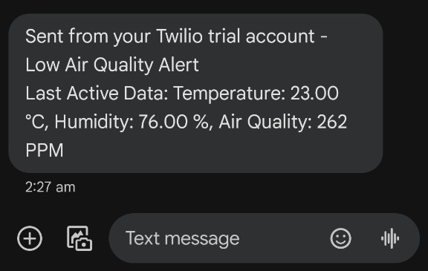
Fig. 5. Automated Alert via Twilio

CONCLUSION

This paper proposes an IoT-based real-time air quality monitoring and alert system using threshold-based trend analysis to provide timely information about the environmental condition. The system, implemented on a NodeMCU ESP8266, MQ-135 gas sensor, and DHT11 sensor, effectively monitors temperature, humidity, and air quality in real time. The system, with real-time data logging using Google Sheets and automated alerts using Twilio, offers accessibility, transparency, and timely alerts when air quality is under specified thresholds.
Unlike machine learning forecasting, the system applies a Simple Moving Average (SMA) approach to identify trends in air quality from recent sensor readings. That way, it is easier to identify deteriorating environmental conditions early enough to allow preventive measures to be implemented. The system is particularly helpful where there is high activity in urban and industrial settings, where air pollution levels will also tend to change frequently.
The scalability of the system will also allow future inclusion of other features, for instance, inclusion of PM2.5 and PM10 sensors for analyzing finer particles. Furthermore, the system could be expanded to a web and mobile-based dashboard, which would enhance real-time monitoring with additional air quality information being disseminated to the general public, policymakers, and environmental agencies.
By offering a cost-effective and scalable solution, this IoT air quality monitoring system facilitates sustainable city development, public health, and environmental conservation. Future advancements in sensor technology and sophisticated data processing methods will also further improve the system's capabilities to offer even more comprehensive and reliable air quality monitoring solutions.

REFERENCES
- S. S. Samal, L. Samal, A. K. Swain, and K. Mahapatra, “Integrated IoT-Based Air Quality Monitoring and Prediction System: A Hybrid Approach,” IEEE International Symposium on Smart Electronic Systems (iSES), 2023.
- V. Gupta, S. Kapadia, and C. Bhadane, “Time Series Analysis and Forecasting of Air Quality in India,” Fifth International Conference on Electrical, Computer, and Communication Technologies (ICECCT), 2023.
- B. Kovacs and R. Rusu-Both, “IoT and Machine Learning-Based System for Predicting, Monitoring, and Controlling Indoor Air Quality,” IEEE International Conference on Automation, Quality, and Testing, Robotics (AQTR), 2024.
- A. R. P. Lima, E. S. S. Rodrigues, and R. S. Silva, “Real-Time Air Quality Monitoring and Prediction Using IoT and Machine Learning Techniques,” Sensors, vol. 20, no. 15, pp. 4200, 2020.
- M. A. A. Mohamad, A. F. Zainal, and M. F. Ismail, “IoT-Based Air Quality Monitoring System with Real-Time Alerts and Predictive Analytics,” Journal of Ambient Intelligence and Humanized Computing, vol. 12, no. 4, pp. 4475-4489, 2021.
- C. Zhang, X. Zhang, and J. Zhang, “Predictive Modeling of Urban Air Quality Using Advanced Machine Learning Techniques,” IEEE Access, vol. 10, pp. 9876-9888, 2022.
- K. Chen, X. Yang, and L. Ma, “Prediction of Air Quality Using IoT and LSTM Neural Networks,” IEEE Internet of Things Journal, vol. 8, no. 7, pp. 5895-5902, 2021.
- L. Wang, Z. Chen, and M. Y. Chen, “Air Quality Forecasting Using IoT Sensors and ML Algorithms,” Computers, Environment and Urban Systems, vol. 78, pp. 101385, 2020.
- T. Y. Nguyen, A. D. Vu, and L. T. Nguyen, “Data-Driven AQI Prediction Using IoT Sensors and ML Models,” Journal of Big Data, vol. 9, no. 1, pp. 1-18, 2022.
- J. H. Park, S. Lee, and T. Kwon, “Implementation of IoT-Based Real-Time Air Quality Prediction System Using Random Forest Algorithm,” Journal of Ambient Intelligence and Smart Environments, vol. 13, no. 4, pp. 327-338, 2021.
- S. Rao, R. K. Jha, and P. Kumar, “IoT and Big Data Analytics for Air Quality Monitoring and Forecasting,” IEEE Transactions on Industrial Informatics, vol. 17, no. 9, pp. 6253-6263, 2021.
- M. Pereira, R. Lima, and J. Sousa, “Challenges and Solutions for Air Quality Prediction in Smart Cities,” IEEE Transactions on Smart Cities, vol. 8, no. 2, pp. 398-411, 2024.
- A. Kumar, P. Ghosh, and N. Sharma, “Smart Air Quality Monitoring System Using IoT and Machine Learning,” Journal of Environmental Management, vol. 277, pp. 111343, 2023.
- R. X. Xu, Q. Wang, and Z. Li, “Using IoT and Hybrid Machine Learning Models for Accurate Air Quality Forecasting in Smart Cities,” IEEE Transactions on Green Communications and Networking, vol. 6, no. 2, pp. 625-636, 2022.
- D. W. Kim, H. Lee, and Y. S. Jung, “Real-Time Air Quality Monitoring and Prediction System Using IoT and Neural Networks,” IEEE Sensors Journal, vol. 21, no. 5, pp. 6719-6726, 2021.
- P. Singh, R. Verma, and S. K. Singh, “IoT-Based Urban Air Quality Monitoring System and Health Alerts Using ML,” International Journal of Environmental Science and Technology, vol. 17, pp. 1731-1745, 2022.
- J. Li, L. Xu, and X. Li, “Deep Learning-Based IoT Air Quality Monitoring System,” International Conference on Artificial Intelligence and Data Science (AIDAS), 2023.
- T. Nguyen, A. H. Le, and K. H. Hoang, “Smart IoT-Based Air Quality Monitoring System with Real-Time Data Analytics,” International Conference on Smart Computing and Communication (ICSSC), 2022.
- A. Sharma, P. Kumar, and N. Singh, “Hybrid IoT Framework for Real-Time Monitoring and Prediction of AQI,” Environmental Monitoring and Assessment, vol. 192, no. 11, pp. 720, 2020.
- Y. Zhang, M. Li, and J. Y. Li, “Smart Air Quality Management System Using IoT and Machine Learning Techniques for Prediction,” Sustainable Cities and Society, vol. 48, pp. 101612, 2020.

